[DATE]
[FIRST NAME] [LAST NAME]
Principal
[SCHOOL]
[ADDRESS]
[CITY], NE [ZIP]
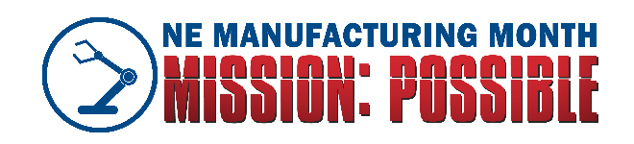

Dear [PRINCIPAL NAME]:
I’m writing you today with a proposal to help build and sustain a strong ecosystem for the creators and makers learning in your classrooms today.
As a top employer of STEM learners and problem-solvers in our region, we recognize that we can provide unique, immersive experiences where students can leverage their talents and test the boundaries of their curiosity. All it takes is a stronger connection between our educators and the manufacturers in our region. Building this connection is the primary goal of Mission: Possible, a program hosted by the NE Manufacturing Alliance during Manufacturing Month (October) in Nebraska.
As a first step in building a long-term partnership in experiential education, we are inviting students and educators to our facility in October for a tour and sneak peek into our thriving community of makers right here in [COMMUNITY].
If conditions this year will not accommodate a field trip, we would be pleased to be guest speakers in your classrooms to discuss the role of manufacturing in our region and our approach to problem-solving.
Students in 5th-grade and above tend to absorb these opportunities best, but we are open to working with educators in any grade level to find a customized program that meets their classroom needs. Could you help connect us with interested educators?
We hope to have plans finalized by mid-September, so we can celebrate with other manufacturers and related industries across the state, and ensure our region is represented well! Please contact me at [PHONE NUMBER] and [EMAIL] to make further arrangements.
Thank you for all you do to build our future problem-solvers, and for considering this opportunity to team up and enhance our STEM ecosystem for all Nebraska students. This truly is our Mission: Possible.
Best regards,

[NAME]
[Title]
[COMPANY LOGO]

