FOR IMMEDIATE RELEASE

Date:
Media Contact:

[COMPANY NAME] celebrates NE Manufacturing with area students

[XX-grade] students see makers in action on tour of local, high-tech operation

[COMMUNITY] – [Number] of [XX]-grade students from [SCHOOL] toured the [COMPANY] facility in celebration of NE Manufacturing, an opportunity for STEM learners to meet the makers and creators making an impact in their communities and nation every day.

Exposing interested students to high-tech career opportunities in manufacturing is the goal of the NE Manufacturing Alliance. The premise of the program is that when manufacturers engage more fully in the classroom-to-career learning ecosystem, both students and manufacturers compete better nationally and globally.

“QUOTE,” said [EDUCATOR OR STUDENT FROM THE TOUR].

On the tour, students observed [WHAT PROCESSES?] and used one-on-one time with operational team leaders to ask additional technical questions.
“QUOTE,” said [COMPANY SPOKESPERSON]

As part of the NE Manufacturing Alliance, manufacturers and related industries are combining forces on a scale larger than ever before on a mission to:

- Support and encourage young Nebraska creators and makers on their educational journeys.

- Help build the STEM toolbox of tomorrow’s innovators and dreamers by partnering with local schools and offering immersive learning opportunities in one of Nebraska’s fastest growing, high-tech sectors.

- Better connect the student talents and interests currently being nurtured by parents and our PK-12 education system to the careers close to home that embrace and encourage creativity, innovative problem-solving and a thirst for lifelong learning.

“Our vibrant, revolutionary maker community is truly one of Nebraska’s hidden gems,” said Bryan Slone, NE Chamber President and Chair of the NE Manufacturing Alliance. “Their work feeds the world, fights disease, connects communities and solves tomorrow’s challenges. When students see the differences they can make in the world from their own hometowns, they will be energized.”

About [COMPANY]

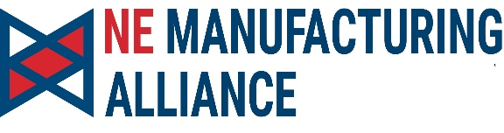
About the NE Manufacturing Alliance
The NE Manufacturing Alliance is a consortium of industry and academic leaders that help drive the advancement of manufacturing in Nebraska, grow and support the next generation of makers, and foster the education and skills required for a successful career in Nebraska’s fastest-growing, high-tech sector. Learn more at https://www.nemanufacturingalliance.com/
###

